Rotary Club of Kathmandu Mid-Town
Breakfast Chatter



20 October 2006 The Weekly Bulletin of Rotary Club of Kathmandu Mid-Town Bc # 16 of 2006-07

District : 3290 Web: www.rotarymidtown.org.np Club Id : 26776

OCTOBER IS VOCATIONAL SERVICE MONTH
In many countries, we are seeing increased youth unemployment. It is very demoralizing to wake up without the prospect of a job. This may lead to poor self-image, despair, even criminal behavior. Rotarians have the means and the ability to provide young people with jobs and an easier start in life. We can inform, we can educate, we can offer training. As community leaders, we already have what is most important - the connections needed for initiatives with other groups and organizations.

Talk program on Managerial Challenges for Development
at the Club meeting on Friday, 13 Oct 2006.
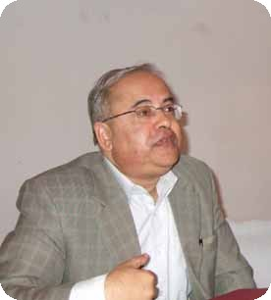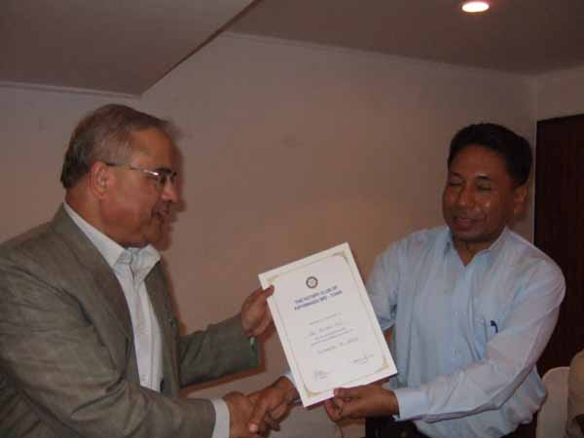
(a) Guest Speaker Prof Dr Bijay Kc addressing at the Club meeting (b) Actg President Subarna Joshi presenting a Letter of Appreciation to the guest speaker.

Weekly Meetings and Programs :
Date | Program/Speaker | Program/Topics of Presentation
20 October 2006 | Rtn Surendra Dhakal | Significance of vocational training in Rotary
27 October 2006 | Dinner meeting | DG's official visit
3 Nov 2006 | Dr Isabella CB Khadka | Past Reminiscences and Present Musings

Friday, 20 October morning :
Rtn Surendra Dhakal, PP of RC Dillibazar, District Chairperson Vocational Training 2006-07, will be talking on significance of vocational training in Rotary. Rotary is an organization of professionals in various classifications, each having expertise, skill, knowledge on specific areas of their profession. The avenue of Vocational Service is meant for diffusing those knowledges and skills of Rotarians to needy people of the society, especially the youth, who are deprived of such opportunities for various reasons, with a view of making them capable of taking up job either on their own or working for other organizations. In Rotary, serving needy people does not mean giving fish to a hungry man rather giving him the skill and equipment to fish so as to help him live a self reliant life. Rotary helps helpless and down-trodden people of the society by providing them skills through vocational training in various professions so that they become capable enough to get income-generating employment.

Joint-Bowling Competition :
On Saturday 14 October, Rotarians, Rotaracts and Interacts enjoyed a joint-bowling competition at Bowling Boulevard, Kantipath amidst a fierce competition. There were four prizes which went one to Rotarian, two to Rotaracts and one to Interact. Rtn Manish K Bhansali bagged the first prize by scoring the highest score whereas Interact Sanu Maya got prize for scoring highest from among the girls. Rtrs Bikram and Kundan each got prize for being first and second in Rotaract group. Everybody enjoyed.
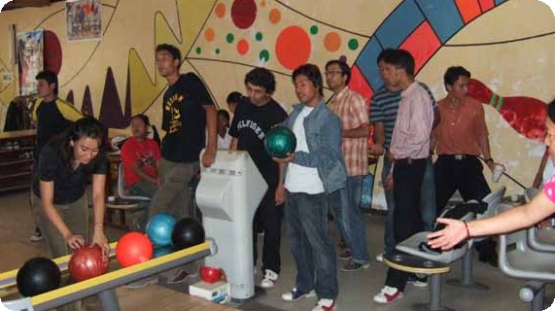
Rotaracts busy in the bowling game.

Tihaar Greetings:

Breakfast Chatter sends Happy Dipawali 2063 to all.

On Lighter Side : Click at the figure ⇩


As Rotarians, we need to think big by expanding our strength through partnerships with other organizations, including governments and major funding organizations. Together, we can break through the layers of bureaucracy and corruption that too often exist in the countries with the greatest needs.
RI President William B. Boyd

20 October 2006 The Weekly Bulletin of Rotary Club of Kathmandu Mid-Town Bc # 16 of 2006-07

Editor: RR Shrestha, Club Service Director email: rryes@wlink.com.np

